MatchMe **Tools** Research

short line

RMIT University  
COSC2408: Programming Project 1

# Ruby on Rails

* A server-side web application framework built on top of the Ruby programming language
* Abstracts and simplifies common, repetitive tasks
* Good for rapid application development

## Rails Tutorial - the basics

### Everyone

<https://www.railstutorial.org/book>

<https://railstutorial-china.org/book/> - Translation

We learned the basics of Ruby on Rails development, testing, and deployment using Michael Hartl’s Rails Tutorial. This includes:

* MVC
* CRUD operations
* Basic user functions (login, logout, registration)
* Test driven development using MiniTest
* Brief introduction to activerecord associations (one to many)
* How to deploy to Heroku
* Image uploading using the Carrierwave Gem and AWS S3

## Rails Guides - activerecord associations and querying

### Jasmine Ellis

<http://guides.rubyonrails.org/association_basics.html>

<http://guides.rubyonrails.org/active_record_querying.html>

Used the Rails Guides to learn how to set up various types of Active Record associations, and different ways to query the database using Rails:

* One to one using [belongs_to](http://guides.rubyonrails.org/association_basics.html#the-belongs-to-association) and has_one association
* Many to many, and [has_many :through](http://guides.rubyonrails.org/association_basics.html#the-has-many-through-association) association to create relationships between models
* [Conditional](http://guides.rubyonrails.org/active_record_querying.html#conditions) querying, querying for [single object](http://guides.rubyonrails.org/active_record_querying.html#retrieving-a-single-object), etc

## Rails Casts - Simple Search Form

### Jasmine Ellis

<http://railscasts.com/episodes/37-simple-search-form>

Learned how to create a simple search form that queries a single column in a table.

## Rails Program Testing Guide

### Xieyang Wu

<https://doc.bccnsoft.com/docs/rails-guides-4.1-cn/testing.html>

How to program unit tests, functional tests, and integration tests for programs,Rails test terminology,Commonly used test methods and plugins

## Rails Program Testing - Simple example

### Xieyang Wu

<http://www.infoq.com/cn/articles/effective-rails-testing>

## iHower - Rails basics tutorial in Mandarin

### Haotian Xu

<https://ihower.tw/rails/index-cn.html>

Basics of Rails, similar to Rails Tutorial. Utilised by teammates who speak Mandarin.

# Match Algorithms

## Inside OKCupid: The math of online dating

### Jasmine Ellis, Hao Li, Haotian Xu, Xieyang Wu

<https://www.youtube.com/watch?v=m9PiPlRuy6E>

How the matching algorithm for OkCupid works.

Also read about various matching algorithms such as Nearest Neighbor Search, though did not attempt to implement them.

## Classical sorting algorithm and ruby implementation

### Xieyang Wu

<https://ruby-china.org/topics/20569>

The sorting and structure of the underlying algorithm

# Heroku

* A cloud Platform-as-a-Service
* Built specifically for deploying Ruby on Rails web applications, now supports other languages
* Uses PostgreSQL database

## Rails Tutorial

### Jasmine Ellis, Xieyang Wu

Basics of Heroku deployment were learned from Rails Tutorial:

<https://www.railstutorial.org/book/beginning#sec-deploying>

<https://railstutorial-china.org/book/chapter1.html#deploying>

Includes instructions on installing relevant gems, adding your SSH key, creating a place on the Heroku servers for the app, and using git to deploy the app to Heroku.

# AWS EC2

* Amazon Elastic Compute Cloud (Amazon EC2) is a commercial web service that allows users to rent virtual machines (or “instances”) to host their applications.
* Users can create, launch, and terminate instances as needed.

## Introduction to AWS EC2 - How to deploy a Rails App to EC2 for the first time

### Hao Li, Haotian Xu

<http://docs.aws.amazon.com/elasticbeanstalk/latest/dg/create_deploy_Ruby_rails.html>

<https://www.youtube.com/watch?v=jFBbcleSPoY>

Researched how to configure an EC2 instance to run a Rails app from scratch.

## Deploying a Ruby app on an AWS production server

### Hao Li

<https://www.phusionpassenger.com/library/walkthroughs/deploy/ruby/aws/nginx/oss/osx/deploy_app.html>

Researched how to deploy a Rails applications to an EC2 instance through Passenger in Nginx.

## Deploying a Rails Application to Elastic Beanstalk

### Hao Li

<http://docs.aws.amazon.com/elasticbeanstalk/latest/dg/create_deploy_Ruby_rails.html>

How to use Elastic Beanstalk Command Line Interface and Git to deploy a Rails application to Elastic Beanstalk

## Connecting to an AWS EC2 Ubuntu instance with Cloud 9 IDE

### Hao Li, Haotian Xu

<https://docs.c9.io/docs/deploying-via-cli><http://fearby.com/article/connecting-to-an-aws-ec2-ubuntu-instance-with-cloud-9-ide-as-user-ubuntu-and-root/>

Setup guide specific to CLoud9 IDE.

# PostgreSQL

* An open source object-relational database system
* Runs on all major operating systems
* Designed for high volume environments

## Cloud9 workspace setup with Rails and Postgresql

### Jasmine Ellis

<https://github.com/Aerogami/guides/wiki/Cloud9-workspace-setup-with-Rails-and-Postgresql>

Learned how to setup PostgreSQL for Rails in the Cloud9 IDE. Includes how to create ENV variables, create a username and password within PostgreSQL, etc.

# MongoDB (NoSQL)

* Open source, cross platform document-oriented database program.
* Uses JSON like documents rather than tables.

## Ruby on Rails Web Services and Integration with MongoDB

### Jasmine Ellis

<https://www.coursera.org/learn/ruby-on-rails-web-services-mongodb>

Researched the basics of MongoDB and how to use it in Rails applications. How to setup your Rails application to use MongoDB, CRUD operations, aggregation, indexing, GridFS, and so forth.

# Model View Controller (MVC)

* A software architectural design pattern that divides source code into three interconnected parts - model, view, and controller.
* Model talks to the database, View generates what the user will see, and the Controller acts as the middleman between the Model and the View, passing on messages between the two.

## Basics of MVC Diagram

### Xieyang Wu, Haotian Xu, Hao LI

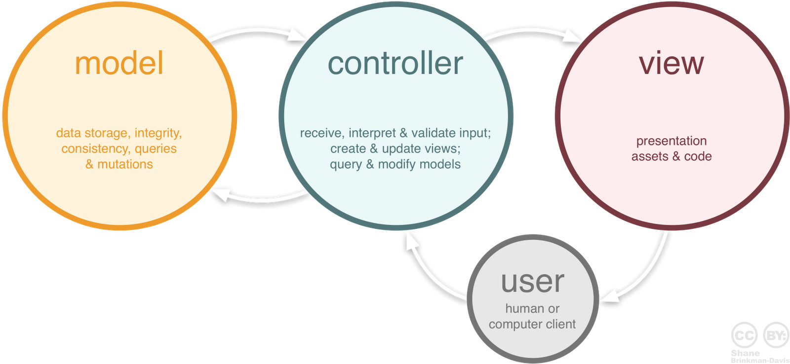

<https://stackoverflow.com/questions/40900741/mvc-variables-in-model-or-controller>

## Intermediate Rails: Understanding Models, Views and Controllers

### Hao Li

MVC and how the design pattern can be utilised in Rails Applications.

## MVC (Model View Controller) in Ruby on Rails

### Haotian Xu

<https://www.youtube.com/watch?v=wV9tcIQTqsE>

# Ruby Geocoder

* A geocoding gem that adds geocoding by location, reverse geocoding, and distance querying.
* Works with PostgreSQL.
* Generates latitude and longitude based on location input in a given object.

## Ruby Geocoder

### Jasmine Ellis

<http://www.rubygeocoder.com/>

<https://github.com/alexreisner/geocoder>

Basic setup guide and utilisation of “nearbys” query. This was especially important when matching users by location. The “nearbys” query uses the latitude and longitude column to compare the current object to all other objects of the same type that are within a set distance range.

# Gzip

## The basic knowledge of gzip and setup gzip on rails.

### Haotian Xu

<https://en.wikipedia.org/wiki/Gzip>

Gzip is an application used for file compression and decompression. When applied to files that make up a web application, the browsing experience is sped up and bandwidth is reduced.

<https://remino.net/remicode/rails-html-css-js-gzip-compression/>

How to setup Gzip compression on Rails applications.

# Domain name

## How do I set up a Host for Dynamic DNS?

### Haotian Xu

<https://www.namecheap.com/support/knowledgebase/article.aspx/43/11/how-do-i-set-up-a-host-for-dynamic-dns>

Researched how to setup a dynamic DNS.

# Git

* A distributed version control system widely utilised by software developers.
* Allows a team of people to work together on a project, all using the same files. Also allows for “backtracking” to previous versions of the project and is useful way to track to progress of an application’s development, especially when used in conjunction with a web-based git repository such as Github.

## Learn Git with Bitbucket Cloud

### Haotian Xu

<https://www.atlassian.com/git/tutorials/learn-git-with-bitbucket-cloud>

How to create a Git repository, copy the repository and add files, pull changes, and merge branches.

## Learn Git Branching

### Haotian Xu

<http://learngitbranching.js.org/>

Used this tutorial to learn several of the basic Git commands.

short dash